Final Exam
African Geography Essays
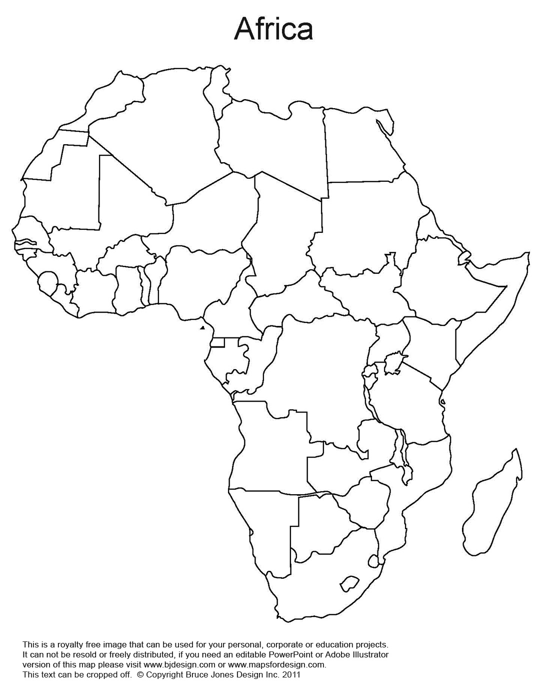
Standards
SS7G1 The student will locate selected features of Africa.
a. Locate on a world and regional political-physical map: the Sahara, Sahel, savanna, tropical rain forest, Congo River, Niger River, Nile River, Lake Tanganyika, Lake Victoria, Atlas Mountains, and Kalahari Desert.
b. Locate on a world and regional political-physical map the countries of, Democratic Republic of the Congo (Zaire), Egypt, Kenya, Nigeria, South Africa, Sudan and South Sudan.
SS7G2 The student will discuss environmental issues across the continent of Africa.
a. Explain how water pollution and the unequal distribution of water impacts irrigation, trade, industry, and drinking water.
b. Explain the relationship between poor soil and deforestation in Sub-Saharan Africa.
c. Explain the impact of desertification on the environment of Africa from the Sahel to the rainforest.
SS7G3 The student will explain the impact of location, climate, and physical characteristics on population distribution in Africa.
a. Explain how the characteristics in the Sahara, Sahel, savanna, and tropical rain forest affect where people live, the type of work they do, and how they travel.

Optional Word Bank:

- Atlas
- Aswan High Dam
- Civil War
- Congo
- Corruption
- Deforestation
- Degradation
- Democratic Republic of the Congo (Zaire)
- Density
- Desertification
- Distribution (unequal and equal)
- Egypt
- Famine
- Fertilizer
- Great Rift Valley
- Kalahari
- Kenya
- Irrigation
- Literacy Rates
- Nigeria
- Niger River
- Nile
- Political unrest
- Pollution
- Poverty
- Scarcity
- Scrubland
- Silt
- South Africa
- Subsistence farming
- Sudan
- South Sudan
- Sahara
- Sahel
- Savanna
- Surplus
- Tanganyika
- Tropical Rain Forests
- Victoria
- Kalahari

- Appraise overpopulation and its relationship to environmental issues in Africa.

SS7G2 The student will discuss environmental issues across the continent of Africa.  c. Explain the impact of desertification on the environment of Africa from the Sahel to the rainforest.  SS7G3 The student will explain the impact of location, climate, and physical characteristics on population distribution in Africa.  a. Explain how the characteristics in the Sahara, Sahel, savanna, and tropical rain forest affect where people live, the type of work they do, and how they travel. | Points: | Your Points:
Write a detailed Outline (at least 10 points)  -you may use one from home | 10
Details to include:
Highlight vocabulary needed | 10
Include Citations | 5
At least one citation will be from a higher level source | 5
Judge why overpopulation and growing population is the under laying cause of all the issue listed below. | 6
Define deforestation, desertification and pollution. | 6
Explain what regions you are likely to see deforestation, desertification, and pollution including why you would see them in these areas. | 6
Describe the Sahel, Savanna, Sahara, and Tropical Rainforest and their approximate location in Africa. | 8
Where (country and region) is desertification, deforestation and pollution growing the most and why. | 2
Determine 2 positives and 2 negatives of the Aswan High Dam. Include the geography region and country. | 5
How do droughts and famines impact the populations of Africa?  Define drought and famine | 6
Decide how national governments are part of the reasons for continuing environmental problems. Use specific countries/industries for full points. | 5
Hypothesize how literacy rates could contribute to environmental issues in Africa. How could improving literacy rates improve the environment? | 10
Discuss possible PRACTICAL solutions to the environmental issues you discussed in this essay. | 10
Conclude the argument reappraising overpopulation and its relationship to environmental issues in Africa. | 6
TOTAL | 100

- Criticize Water Issues in Africa.

SS7G2 The student will discuss environmental issues across the continent of Africa.  a. Explain how water pollution and the unequal distribution of water impacts irrigation, trade, industry, and drinking water.  SS7G3 The student will explain the impact of location, climate, and physical characteristics on population distribution in Africa.  a. Explain how the characteristics in the Sahara, Sahel, savanna, and tropical rain forest affect where people live, the type of work they do, and how they travel. | Points: | Your Points:
Write a detailed Outline (at least 10 points)  -you may use one from home | 10
Details to include:
Highlight vocabulary needed | 10
Include Citations | 5
At least one citation will be from a higher level source | 5
Judge why water is such a critical issue in areas like Africa  Define unequal distribution. | 6
Explain the significance of the major lakes (2) and rivers (3) in Africa. | 6
Explain what regions you are likely to see having water scarcity.  Define Arid and Semi-Arid | 6
What are some major sources of water pollution? | 6
How does over population contribute to water issues in Africa? | 4
Determine 2 positives and 2 negatives of the Aswan High Dam. Include the geography region and country. | 5
What is the Green Line? Is it a literal line? What country are you most likely to see the Green Line in? | 5
How do droughts and famines impact the populations of Africa?  Define drought and famine | 6
Hypothesize how literacy rates could contribute to environmental issues in Africa. How could improving literacy rates improve the environment? | 10
Discuss possible PRACTICAL solutions to the environmental issues you discussed in this essay. | 10
Conclude the argument reappraising water and its relationship to environmental issues in Africa. | 6
TOTAL | 100

- Appraise natural resources and/or scarcity of natural resources in Africa.

SS7G2 The student will discuss environmental issues across the continent of Africa.  c. Explain the impact of desertification on the environment of Africa from the Sahel to the rainforest.  SS7G3 The student will explain the impact of location, climate, and physical characteristics on population distribution in Africa.  a. Explain how the characteristics in the Sahara, Sahel, savanna, and tropical rain forest affect where people live, the type of work they do, and how they travel. | Points: | Your Points:
Write a detailed Outline (at least 10 points)  -you may use one from home | 10
Details to include:
Highlight vocabulary needed | 10
Include Citations | 5
At least one citation will be from a higher level source | 5
What are the major Rivers and Lakes in Africa and why are they an important resource | 5
Explain what regions you are likely to see Oil, Gold, Diamonds, Rain Forest, Tourism including why you would see them in these areas.  Appraise surplus or scarcity of natural resources the different regions of in Africa using specific resources. | 15
Evaluate the differences between arable land and aridity. Which regions have more aridity and which have more arable land.  Include the Green Line. | 10
Hypothesize why deforestation, desertification, and pollution could begin to limit natural resources. | 4
How do droughts and famines impact the populations of Africa?  Define drought and famine | 5
Determine 2 positives and 2 negatives of the Aswan High Dam. Include the geography region and country. | 5
How does over population contribute to environmental issues in Africa? | 5
What is the Green Line? Is it a literal line? What country are you most likely to see the Green Line in? | 5
Hypothesize how literacy rates could contribute to environmental issues in Africa. How could improving literacy rates improve the environment? | 10
Discuss possible PRACTICAL solutions to the environmental issues you discussed in this essay. | 10
Conclude the argument reappraising scarcity or surpluses of natural resources in Africa and its relationship to environmental issues in Africa. | 6
TOTAL | 100
- Hypothesis the relationship between Social Studies and Science physical geography and climate and its effects on Africa
SS7G2 The student will discuss environmental issues across the continent of Africa.  a. Explain how water pollution and the unequal distribution of water impacts irrigation, trade, industry, and drinking water.  SS7G3 The student will explain the impact of location, climate, and physical characteristics on population distribution in Africa.  a. Explain how the characteristics in the Sahara, Sahel, savanna, and tropical rain forest affect where people live, the type of work they do, and how they travel. | Points: | Your Points:
Write a detailed Outline (at least 10 points)  -you may use one from home | 10
Details to include:
Highlight vocabulary needed | 10
Include Citations | 5
At least one citation will be from a higher level source | 5
Hypothesis the relationship between Social Studies and Science. Evaluate how physical geography and climate and its effects on Africa | 6
Analyze the Rain Shadow effect. What is it, what regions cause it and what regions does it effect? Be specific!!!! | 10
Explain what regions you are likely to see having water scarcity.  Define Arid and Semi-Arid | 4
Describe the Sahel, Savanna, Sahara, and Tropical Rainforest and their approximate location in Africa. | 6
Explain what regions you are likely to see deforestation, desertification, and pollution including why you would see them in these areas. | 5
How does over population contribute to environmental issues in Africa? | 2
Determine 2 positives and 2 negatives of the Aswan High Dam. Include the geography region and country. | 5
What is the Green Line? Is it a literal line? What country are you most likely to see the Green Line in? | 2
How do droughts and famines impact the populations of Africa?  Define drought and famine | 4
Hypothesize how literacy rates could contribute to environmental issues in Africa. How could improving literacy rates improve the environment? | 10
Discuss possible PRACTICAL solutions to the environmental issues you discussed in this essay. | 10
Conclude the argument reappraising water and its relationship to environmental issues in Africa. | 6
TOTAL | 100

- Compare and contrast the different major geographic regions, major lakes, and major rivers
SS7G2 The student will discuss environmental issues across the continent of Africa.  c. Explain the impact of desertification on the environment of Africa from the Sahel to the rainforest.  SS7G3 The student will explain the impact of location, climate, and physical characteristics on population distribution in Africa.  a. Explain how the characteristics in the Sahara, Sahel, savanna, and tropical rain forest affect where people live, the type of work they do, and how they travel. | Points: | Your Points:
Write a detailed Outline (at least 10 points)  -you may use one from home | 10
Details to include:
Highlight vocabulary needed | 10
Include Citations | 5
At least one citation will be from a higher level source | 5
What are the major Rivers and Lakes in Africa and why are they an important resource? | 5
Explain what regions you are likely to see Oil, Gold, Diamonds, Rain Forest, Tourism including why you would see them in these areas.  Appraise surplus or scarcity of natural resources the different regions of in Africa using specific resources. | 8
Define Surplus and Scarcity | 2
Evaluate the major causes for environmental degradation in Africa including deforestation, desertification, and pollution. | 8
Hypothesize which regions are growing and shrinking in Africa and evaluate the role of overpopulation and growing population in this process. | 7
Explain what regions you are likely to see having water scarcity.  Define Arid and Semi-Arid | 4
How do droughts and famines impact the populations of Africa?  Define drought and famine | 5
Decide how national governments are part of the reasons for continuing environmental problems. Use specific countries/industries for full points. | 5
Hypothesize how literacy rates could contribute to environmental issues in Africa. How could improving literacy rates improve the environment? | 10
Discuss possible PRACTICAL solutions to the environmental issues you discussed in this essay. | 10
Conclude the argument reappraising the geographic regions relationship to environmental issues in Africa. | 6
TOTAL | 100

