Founder: Jesus + Jewish heritage
Huge expansion: conversion encouraged and spread by Roman Empire
Christianity
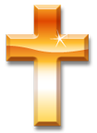

Founder: Abraham
Judaism
Holidays: Christmas and Easter
Place of Worship: Church
Holy Scripture: Torah (Old Testament) + ideas of Jesus (New Testament) = Bible
Place of Worship: Synagogue
Holidays: Passover and Yom Kippur
Diaspora: limited growth-no conversion allowed
Region: Middle East/ Israel
Holy Scripture: Torah

