Middle East GUIDED NOTES
Standard SS7G7
Nomads


Irrigation
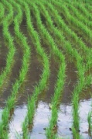

Agriculture

Civilization


Mesopotamia
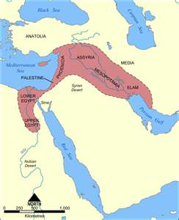

Cuneiform
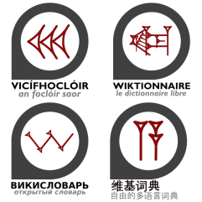
Hammurabi and Code of Laws
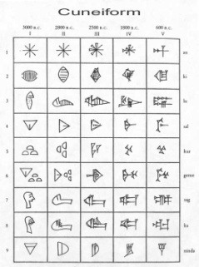
Natural resources


Oil

Fresh Water


Arable land

Distribution


Climate


OPEC

